MICHELE FRANZINI
Jazz pianist, composer, arranger, based in Milano (Italy)
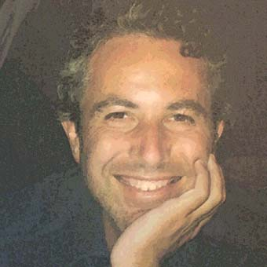
While studying classical music (piano, with Izabela Zielonka, then harmony and counterpoint), he performed in national piano competitions with brilliant results.
He graduated "summa cum laude" in Jazz, Second Level Academic Diploma at Conservatorio "N.Paganini" in Genova, with Pietro Leveratto.

He developed his own distinctive sound, studying jazz and performing as a soloist, composer and arranger in many groups in Italy, recording or playing, among others, with Brian Lynch, Mauro Negri, Lee Konitz, Fabrizio Bosso, Paula Santoro, Rudy Royston, Emanuele Cisi, Larry Schneider, Francisco Mela, Tollak Ollested, Andrea Dulbecco, Greg Osby, Tiziana Ghiglioni, Pietro Leveratto, Luca Aquino, Tito Mangialajo Rantzer, Massimo Manzi, Tino Tracanna, Attilio Zanchi, Michele Salgarello, Dimitar "Mitko" Liolev, Massimo Pintori...

In jazz clubs, festivals and concert halls, he had the opportunity to express himself within several different kind of situations, from big band to duo, from traditional jazz to free forms, becoming a well-appreciated teacher, too.
PRESS:

the record presents ten Franzini pieces that fall within the mainstream/progressive Bop arena, with an air of mistery that adds to the emotional content of the majority of these excursions...
…a sound that demonstrates a firm grasp of the modern mainstream players (Hancock/Tyner et al.)…
…as for the addition of Brian Lynch, the hookup works wonderfully…
…the strongest tracks, though, are those that utilize Franzini's keen writing abilities that play with expectations…
…a definite keeper that demonstrates the continuing vitality of italian jazz.
(CADENCE April 2006)

the music exhibits the ability to motivate action through the united drive of the trio.
ripe rhythms are integral to the music, making the pace typically lively and the spirit highly active.
…They keep the wheel spinning with a balanced attack of intricate improvisations constructed under attractive melody lines. It results in an attractive trio package of improvised music.
(CADENCE April 2004)

